Campaign Notes

* The campaign takes place in y514. The Rains have caused widespread disease and famine that have likely wiped out Lord Rothchild’s settlement in Caigenhurst.
* Baron Christopher Pelgrim has tasked Lady Sophia Riga with exploring the Caigenhurst, learning what has happened to Rothchild and restoring civilization to the wild region.
* PCs will play the advisors and troubleshooters to the Lady, as well as the primary exploration group on the island.

May 1st, y514, Session One – Advanced Scouts

* The PCs have been contracted by Wallace (bushy red hair, spectacles, fine coat), Lady Riga’s steward, to be the advanced scouting party. Their mission is to explore and secure the docks, the village of Roth, and the manor house in preparation for the arrival of the Lady and her entourage.
* The group has traveled in two boats, the Swan (larger) and the Sparrow, both led by Captain Quillan (scowling, unkempt, a tiny bit hunched), who has made trips to the Caigenhurst before.

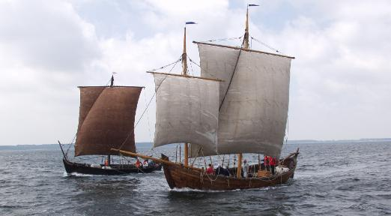

*It has been nearly three weeks since you set off. Three weeks on the cramped boat, an arm’s reach from the angry sea. The Mother has kept you safe and given you the wind you needed. More importantly, She’s kept the storms from you, for though the sky has been thick and grey your entire journey, you have been subject to nothing more than gentle rain. And indeed when you finally spot land, it is through squinted eyes and the obscuration of a cold, soaking rain.*

* The boats come to within 200 or so yards from shore, but then lower their sails and drop anchor. Quillan informs Wallace and the PCs that the Swan cannot get too close to shore here, due to dangerous shoals. The PCs will have to take the Sparrow in by oar.
* Due to the trip and the miserable weather, PCs are suffering from ***bad morale*** until they can get some real shelter, or if they have some way of mitigating the weather.
* As the PCs, Wallace, and 3 men-at-arms row the Sparrow closer to shore, they can see the Old Rotten Docks.

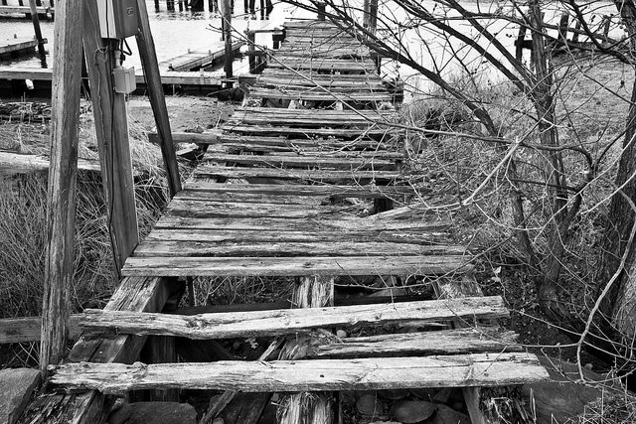

*You row the boat toward land, being mindful of the rocks that glide just inches below you. The shore is close and you proceed toward the mouth of a small, shallow river and what remains of a rotting dock and few structures that have been battered by the recent storms. To the west, you can see the remains of a small fishing vessel stuck on some rocks.*

* This location consists of the dock, wrecked scaffolding, two sheds, and some small huts that are not much more than piles of stones now, a broken down warehouse and a small stone building a bit further inland that looks to be mostly intact.
* There isn’t much on the beach. The docks are a mess, rotted and overgrown. The scaffolding was used to build new fishing boats. It has been battered by the storms, but could be salvaged by someone with engineering. The sheds contain tools, wood, stone and other construction materials. Not enough for new construction, but certainly enough to enact a few simple repairs.
* The warehouse is fairly large, and about a third of it has collapsed. (Two bodies here, buried in debris, eaten by rats.) It contains two rowboats, oars and rope. Also, there are about two dozen crates, many of which are cracked open, spilling their contents of grain and nasty rotted fruit onto the wooden floor. Rats scurry everywhere, but are no threat to the PCs.
* The other thing here, slightly more disturbing is that several small pools of tarry, black rain have settled here. This place will have to be cleansed before it is usable again.
* The shipwreck is a fishing boat that got loose from its moorings and was dashed upon the nearby rocks. If PCs investigate the wreck, they find a survivor named Camille. Camille is a fisherwoman who came to Caigenhurst with the first settlers. She was on the boat when it crashed and has two broken legs. She has been here for over three weeks, hiding in the wreck and living off of the fish that occasionally stray too close to her makeshift spear.
  + Camille will warn the PCs about the fishing master and his ghoulish family, because she has seen them scour the beach, picking up the corpses and picking off survivors.
  + Camille will ask if the PCs have seen another boat, like this one, that was torn out to sea and disappeared. She thinks her brother was on that boat, trying to save it, when it was lost.
  + Camille is in serious condition. She is nearly starved and her legs are in need of medical attention.
* The stone house is the main attraction here. It was the house of the fishing master and his family who were caught in the rain when it struck. Their long exposure turned them into ***weepers***, a special type of ghoul caused by the magic in the black rain.
* As PCs approach the house, they might hear the sound of raspy breathing, vile retching, greedy munching and lip-smacking and clattering bones – all coming from the back of the house.

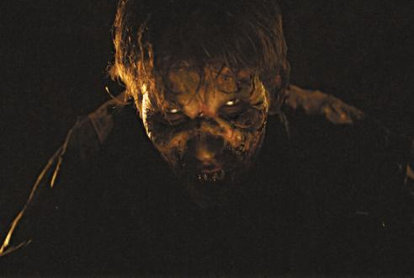

*As you round the corner of the house, you see a pack of humanoids crouched around a large pool of stinking black liquid in which you can see the remains of several partially eaten corpses. They alternate between gnawing at the bones of the unfortunate villagers, and greedily lapping at the vile liquor. Their hands and clothes are stained in blood and gore, and their eyes are welling up with black tears that run down their cheeks.*

*When they see you, they are momentarily confused and for some reason look at their hands, then the pool, and then back at you. Their eyes flicker for a second and they try to speak. But when they do, only the tar bubbles from their lips. Then they are overcome with rage and they charge to the attack.*

* The house itself is not outstanding, but it is still intact and relatively unsullied by the chaos outside. This would be a great place to rest, build a fire, and work of the ***bad morale*** status.
* There are a few items of interest here:
  + A huge fish? scale hangs on one of the walls here. It is labeled “Grunnich”. It could be used to make some kind of shield perhaps. And maybe other people in the region know about Grunnich?
  + Some prime fishing gear is here, giving anyone fishing a +1 to their survival skill
  + 4 doses of Fly Choke herbal treatment – keeps insects away for about 1 day
  + 3 doses of decent perfume
  + Some petty cash (if anyone asks, say about 72p258b)

May 3rd, y514, Session Two – Basement Dwellers

* Session one gave ***two*** ***free checks*** – one for the evening and another for clearing the black pool near the stone house.
* Characters have made their way to the village of Roth and have met three NPCs there
  + Bordas – The village reeve
  + Father Grimm – The priest of the Church of the Bountiful Orchard
  + Ingrid – Village baker and hostess of visitors
* From these NPCs, they have learned that Rothchild is dead and that his manor has been taken over by a ratling named Grimjaw. Grimjaw has offered peace to the humans in exchange for them not interfering with his ownership of the manor and the nearby lands.
* They have also learned that there is a pool of black goop in the field outside of Ingrid’s house.
* They have also learned that Ingrid has something of an issue at her house. Several weepers are trapped in her basement. One of them is Ingrid’s mother. No one is quite sure what to do with these unfortunates.
* Clearing the basement isn’t too big of a deal. There are four weepers down there, and though they will hide very well and ambush anyone that comes down there, they will likely be easy to dispatch. The basement is storage for all of Ingrid’s food and drink, and it is a mess. Not only have the weepers wrecked a lot of stuff, but the black goo from the field seems to have seeped in. In fact, the seeping goo infected the ale casks and that is what caused the weepers in the first place.
* If PCs decide to kill the weepers, Ingrid will be mortified and will likely need to be persuaded (DL 15) to not blame herself and be angry at the PCs.
* If PCs decide to aid the weepers, it will require one dose of the cleansing agent and take a physician skill roll (DL 18) to succeed. Regardless of the outcome of the treatment, Ingrid will be forever grateful to the PCs and treat them like beloved friends.

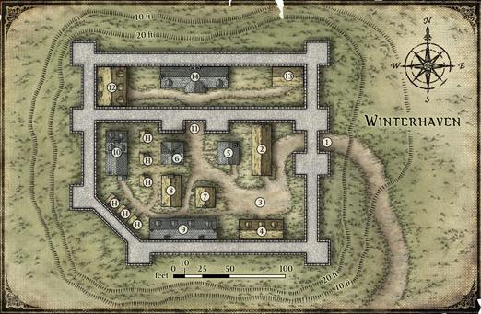

1 Outer Gate  
2 Wrafton's Inn  
3 Market Square  
4 Stables  
5 Smithy  
6 Valthrun's Tower  
7 General Store  
8 Warrior's Guild  
9 Tenements  
10 Temple  
11 Inner Gate  
12 Siege Supplies  
13 Barracks  
14 Manor House

* The next issue is the ratlings at Rothchild Manor
  + Grimjaw and his crew are the underlings of the ratling “sorceress” Pashka. She is looking for a rune (the nature of which I am uncertain of at this time, but it has something to do with Toron, the underworld and Borakki).
  + In researching the rune, she learned that the way to its site was contained in a relic called the Book of Blood.
  + This book is rumored to have been kept by one of the tribes of Ghost Grunj that live in deep wilderness of the Caigenhurst.
  + Pashka traveled to these tribes to find the book, but had been beaten there by Rothchild, who wiped out a village and stole the book.
  + In the meantime, Rothchild studied the book, but found it entirely blank. He examined it a dozen ways, but could not decipher its secrets. However, he did contract a strange bleeding disease where he would spontaneously erupt into numerous small sores, oozing blood.
  + His wife and assistant (also the court physician) contracted the same disease soon afterward and all three of them were quarantined. The sores kept bleeding, but now it was becoming obvious that something unnatural was happening – the wounds from the sores formed pictures and words. (The three afflicted peoples’ skin forms a map when stitched together. And… that got dark quickly!)
  + The manor priest, Father Billings, realized that the disease was somehow linked to the strange relic the three were pouring over. He assumed they had brought down a curse and once all of the afflicted died, he tried having the bodies burned, but could not.
  + Instead, he found an ancient tomb in the woods near the manor, and had the three bodies, now etched in runes, and the blank book, buried in the crypt. He went insane soon after and fled the manor, just before the rains (and the ratlings) came and wiped out the rest of the inhabitants. Billings is in a hut somewhere in the woods, sketching the runes he was not meant to see over and over and over.
  + Grimjaw and his crew of 12 ratlings (with a selection of brown ratling captives) are here, trying to find Rothchild and his book. They are digging up the entire manor, but have found only servants and villagers. They have not yet found the crypt.
* If the PCs try to talk to Grimjaw, they will be allowed to the manor. However, they will not be allowed to carry any weapons inside, or cast spells. The hawk will be able to fly over the manor, but the ratlings are fond of taking potshots at pretty much any critter that strays too close.
* Grimjaw is arrogant and certain of his superiority over humans. He will be polite, but dismissive unless the PCs are offering something to him. He insists that the land was vacant before the ratlings moved in (not entirely true) and that he and “his mistress” are entitled to it.
* Here are some possible topics of conversation:
  + Why are you here? – We are here because for years we have lived like common rabble, in ruins or burrows, content to simply seek shelter from the sky. My mistress has declared that we shall live as a people free of such fears. This land was ours generations ago, before the Borakki and the grunj forced us away. We are here to reclaim it.
  + What happened here? – I cannot say, but this place was abandoned by your kind long before we arrived here. The only thing left here were corpses. Disease, I imagine. Your kind are so very fragile.
  + Church/Priest – There were no human priests here when we arrived and we have not defiled your church in any way. If you like, as an offering of peace, I will allow you to enter your church to reclaim any religious relics left behind.
  + The dead – Burned or buried. I mourn the loss of your brothers and sisters.
  + Lady Riga – I am here, your lady is not. Your lady may be powerful, but her claim on this land is dubious at best and right now, seems only as good as her agents’ willingness to risk their lives to enforce it. On the other hand, all I am asking is that this single place be left as a sanctuary for my people and the rest of the Caigenhurst is left for your noble lady.
  + Digging – Digging? Digging? Oh, that is none of your business, human. Let us just say that I want to plant a garden and leave it at that.
  + Rothchild – I knew ***of*** your Lord Rothchild, but never had the pleasure of meeting him. I have heard rumor that he died on an expedition far north of here.
* The church has been left untouched by the ratlings because of their fear of the human gods. There are a few religious articles here and saving them will give believers a ***blessed*** status.
* More importantly, Father Billings’ journal is here and he describes many of the events that led to the destruction of Rothchild.
  + “The lord has returned from his latest expedition triumphant. This is good, since I need to talk to him about hiring some laborers from Roth. Both the roof and windows are in need of repair…”
  + “…when I entered his chamber, he was in a heated discussion with Dr. Ombras. Something about an old book, which was seemingly too important for my eyes, as they rushed to close and hide it as I entered. Their concern was strange, since the only glimpse I caught was that of two blank pages. Still, something about that whole scene makes me uneasy.”
  + “I have been meaning to discuss these blasted windows with Rothchild for well over a week now, but Ombras has been turning me away. Father forgive me, but I cannot stand that man. He is behaving well above his station. I will see the lord in spite of him, but he seems to never leave the lord’s chambers, so I will need to be patient.”
  + “Father, please save us! I set out to discuss the chapel repairs with Lord Rothchild and so I waited for an opportune moment to sneak into his chambers. I wish now that I hadn’t, for when I entered, I was greeted with the sight of both Lord and Lady Rothchild in bed, deathly pale, and covered in a patchwork of bandages, ointments and salves. All of this to treat a myriad of horrible, bleeding sores that have appeared on their skin. It was horrible.”
  + “Even more terrible was the surprise return of Ombras, who had gone only to get even more bandages from his office. He chided me for not heeding his warnings and told me that the Lord had contracted some sort of malady, probably from his contact with the Ghost Grunj during his last expedition. But Ombras had been on that expedition as well. Why wasn’t he sick? He showed me his arm, covered in the same sores as poor Lord Rothchild. Ombras was ill too, and when he saw the horror in my eyes, he laughed at me and said I may be infected now as well.”
  + “As it turns out, I have not fallen prey to the same malady as Rothchild and Ombras. Thank the Father. However, the pox have spread to his hands and face, so Ombras is no longer fit to be seen. That means I am in charge of nursing them. I do wish we had a priestess here. They are not recovering. If anything, their skin is getting worse. Indeed, I am alarmed at the amount of blood seeping from their wounds each day. They live, but they are wasting away.”
  + “One of the soldiers made a disturbing confession today. When he was with Rothchild on his latest excursion, they came across a village of grunj living deep in the wilderness. Rothchild and Ombras were looking for something there and when negotiations failed, the boy said the soldiers were given the order to destroy the village and kill any who resisted. If they found the book, they were not to touch it for any reason, but to tell the lord. The entire village was wiped out, down to the last child.
  + “I knew the end of this story, but I asked the boy anyway because I had to know for sure. What of the book? He saw it, and it was as I feared, a blank book. Rothchild and Ombras killed an entire village of grunj in their search for some relic. And now they are cursed with these sores that will slowly bleed them to death. Am I wrong to be relieved? At least the rest of us will be spared the horror of their disease. But, what else does the curse have in mind for us? I will save this manor by disposing of these three wretched souls and their confounded book.”
  + “My mission is even more critical than I originally thought. Once they passed, their bleeding stopped and the scabs on their skin fell away. They’re not covered in sores. They’re covered in writing… beautiful”
  + “There is an old crypt hidden away in the woods to the north of here. I think it is Borakki in origin. They bodies won’t burn. The book won’t burn. A feeling of unease has come over me that I cannot adequately describe. I must hurry.”
  + “It is done. I collected the boy and a few of his fellow  and told them it was time to  themselves for the murders of the . We broke the seal on the Borakki  and threw the bodies of Lord and Lady Rothchild and Ombras . Then, we  it as best we could. I am seeing them in my . This place  like a prison. I am not sure how much longer I can  here. Father bless us all.”